CS 255 System Design Document Template

Name: Sudarshan Acharya
June 18, 2026

UML Diagrams

UML Use Case Diagram
[In Module Six, you were asked to complete a use case diagram based on your system design. If you would like to make any adjustments to your diagram, please do so. Please insert your use case diagram here. Check to make sure that you included appropriate components and symbols and that your design meets the client’s needs.]

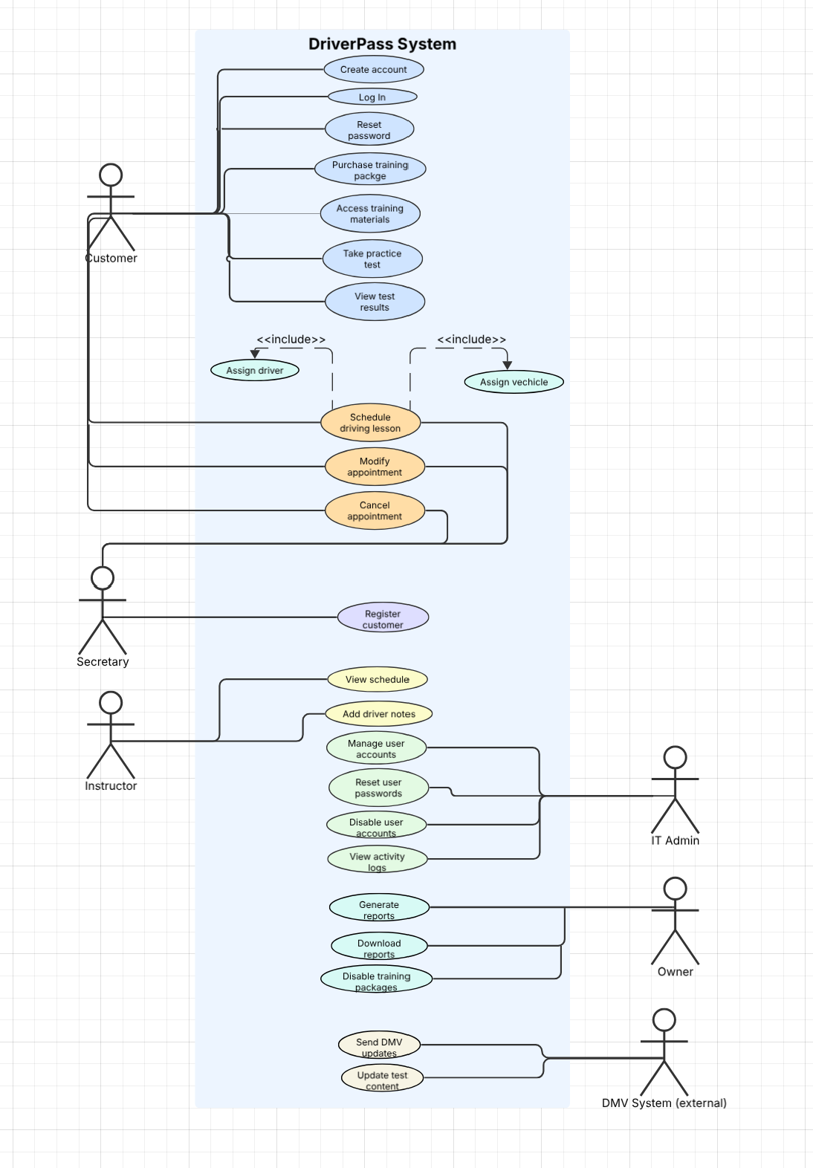

UML Activity Diagrams
[You were asked to choose two use cases and create two activity diagrams, one for each use case. Please insert both of your activity diagrams here. Check to make sure that you included appropriate components and symbols and that your design meets the client’s needs.]

Activity #1
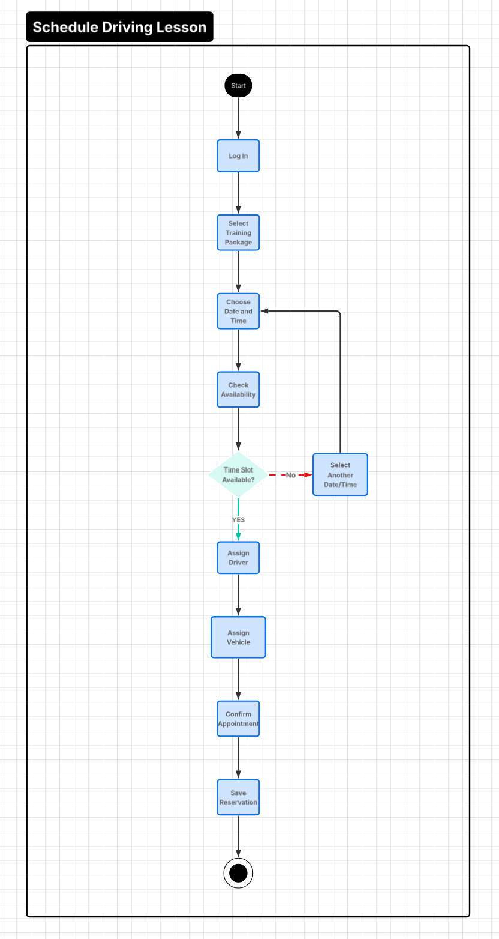

Activity # 2
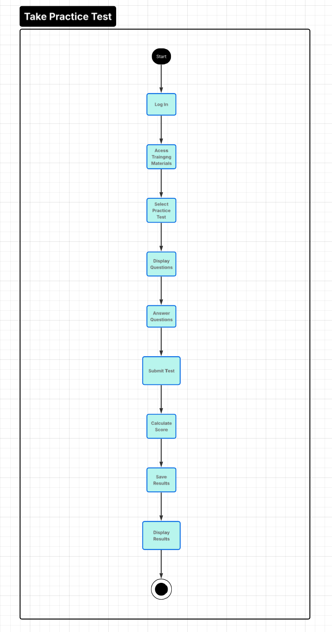

UML Sequence Diagram
[You were asked to create a sequence diagram based on one of the use cases you chose. Please insert your sequence diagram here. Check to make sure that you included appropriate components and symbols and that your design meets the client’s needs.]
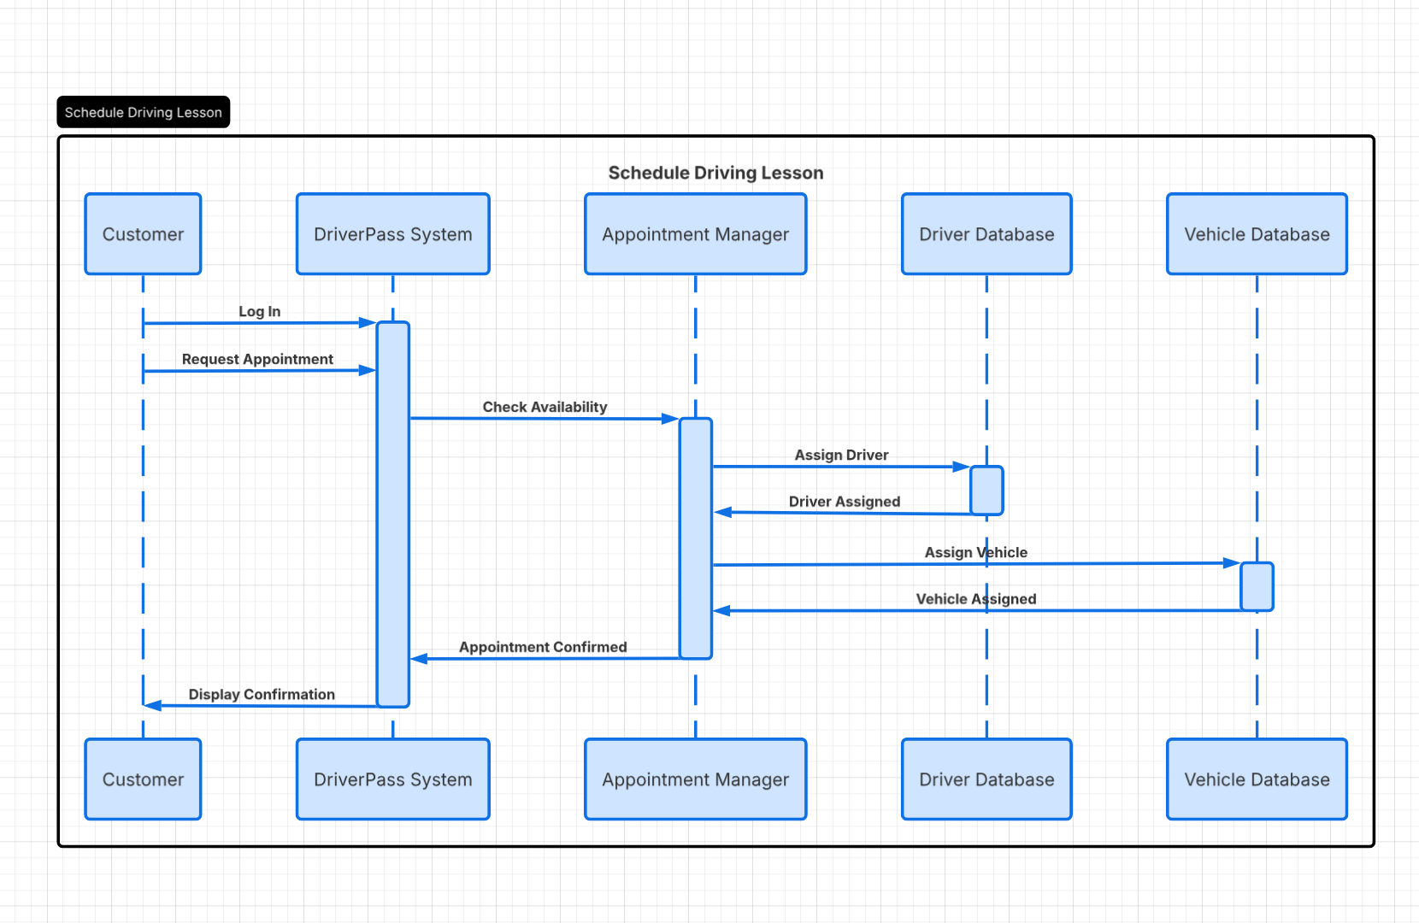

UML Class Diagram
[You were asked to create a class diagram based on the different classes and attributes needed for your system design. You are not required to include methods, but you may if you wish. Please insert your class diagram here. Check to make sure that you included appropriate components and symbols and that your design meets the client’s requirements.]
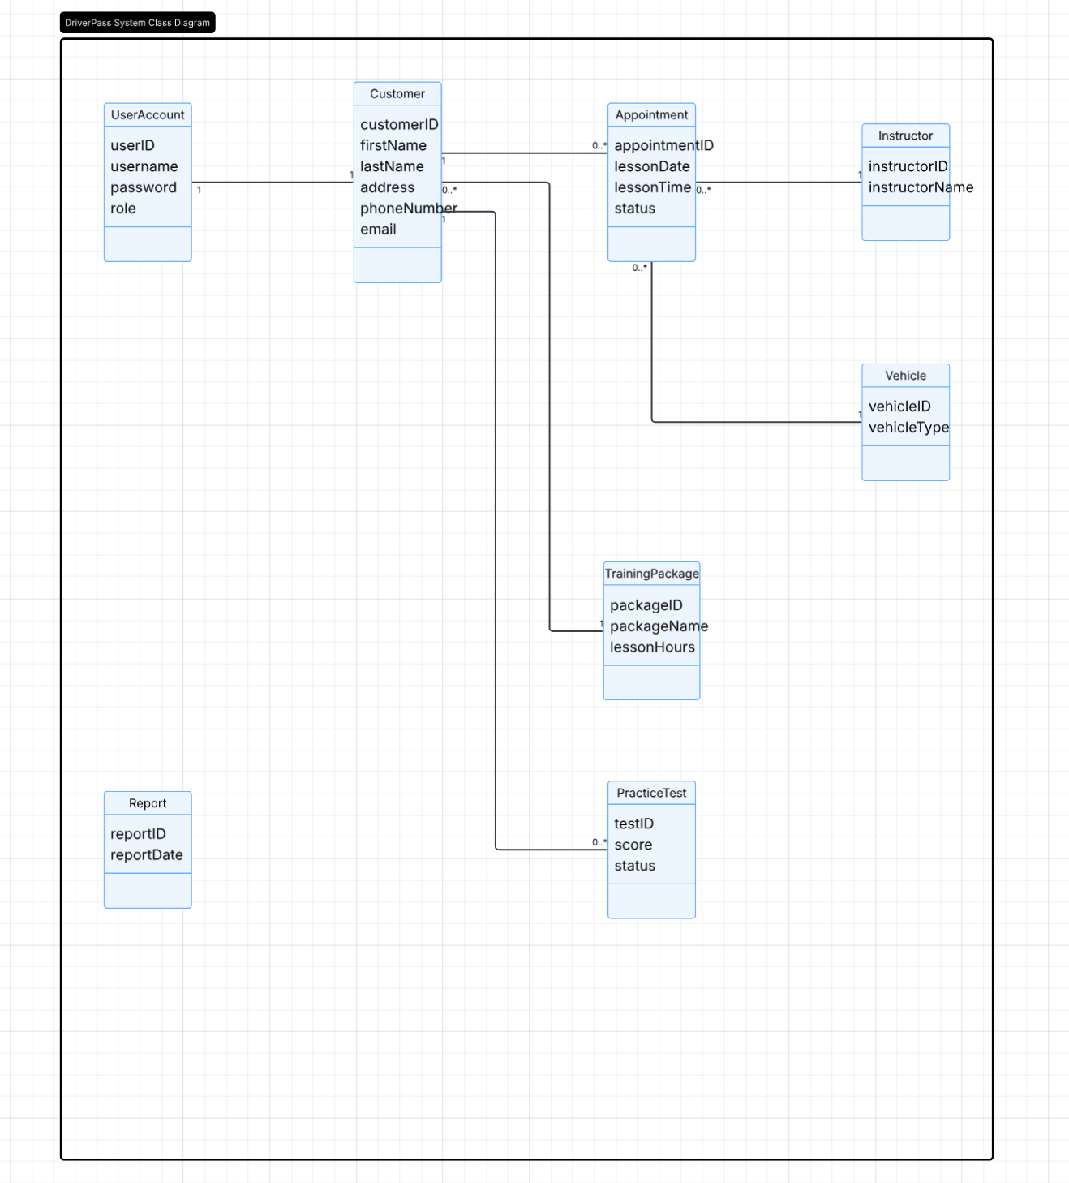

Technical Requirements

The DriverPass system has to be an online platform since it needs to be accessible by both customers and employees from different locations. Since DriverPass wants customers to schedule driving lessons, take practice tests, and view training materials online, the system should work on different devices such as computers, tablets, and mobile phones.
DriverPass will also need servers and storage to keep customer information, appointment records, lesson schedules, practice test results, and activity logs. Since DriverPass wants to access information from different places, a cloud-based system would be a good option. This would allow employees to manage the system even when they are not working from the same office.
The system should also support account management, lesson scheduling, practice tests, training materials, and report generation. Customers should be able to create accounts, log in, reset passwords, and manage their appointments. Employees should also be able to manage customer information and generate reports when needed. Because DMV rules and practice test questions may change over time, the system should be able to receive updates so that the information remains current.
Security is also important because the system stores customer information and payment details. Each user should have their own account and password, and access should be limited based on the user's role. The system should also keep a record of appointment activity so DriverPass can identify who created, modified, or canceled a reservation if a problem occurs. Overall, these technical requirements support the goals of DriverPass by allowing customers to access training services online while giving employees the tools needed to manage appointments, customer records, and other daily business activities.

